Important: Keep Travel requirements in mind when making vacation plans. Both International and Domestic travel quarantine rules may still apply. Plan accordingly so that your child does not miss Religious Education.
Religious Education Calendar 2022-2023
All Dates and times are subject to change. Please refer to the Handbook for questions regarding Hurricanes. All communication will be done via email.

September 1, 2022: Registration Closes for the 2022-2023 School Year
September 11, 2022: First Day of Religious Education Class/ Parent Welcome
September 25, 2022: Last Year Confirmation Students: Data Sheet, Contract, Baptismal Certificate, and Sponsor Letter MUST be turned in

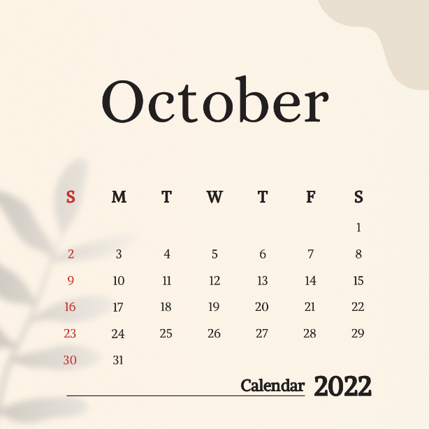

October 2, 2022: STUDENTS MUST ATTEND WITH THEIR FAMILIES Respect Life Sunday- children bring donated baby items up during the offertory at the 9:30am mass
October 9, 2022: STUDENTS MUST ATTEND WITH THEIR FAMILIES Blessing of the Rosary during the 9:30am mass
October 15, 2022: Last year Confirmation Students, Parents, and Sponsors must attend the Confirmation Commitment mass at 5:00pm and meeting at 6pm

November 13, 2022: Virtus Class (Opt out form will be sent home or sent via email; Please sign and return if you do NOT want your child to participate)

November 27, 2022: No Class- Happy Thanksgiving

December 25, 2022: No Class- Merry Christmas!

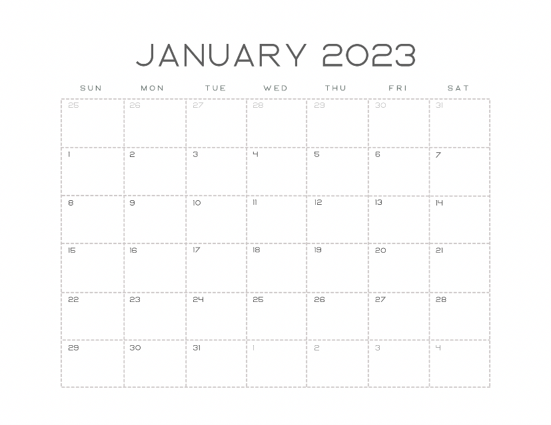

January 1, 2023: No Class- Happy New Year
January 15, 2023: No Class- In observance of Martin Luther King Jr. Day

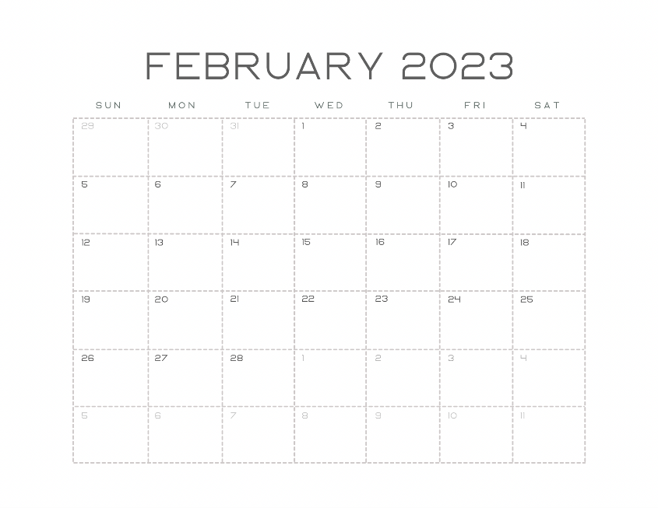

February 19, 2023: No Class- In observance of Presidents Day

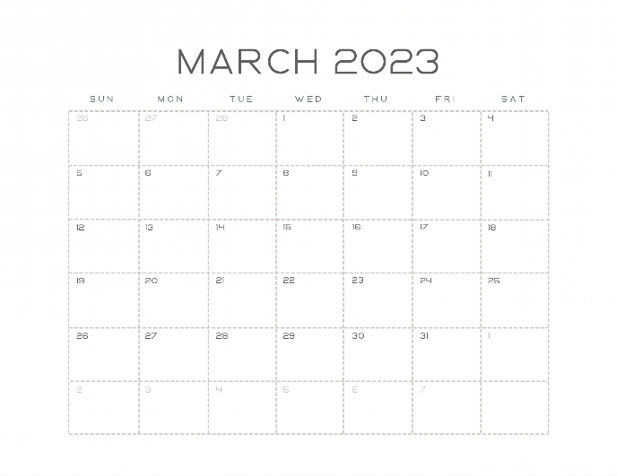

March 12, 2023: No Class Go have fun and support your Parish at the Jamboree!
March 19, 2023: No Class Broward School’s Spring Break

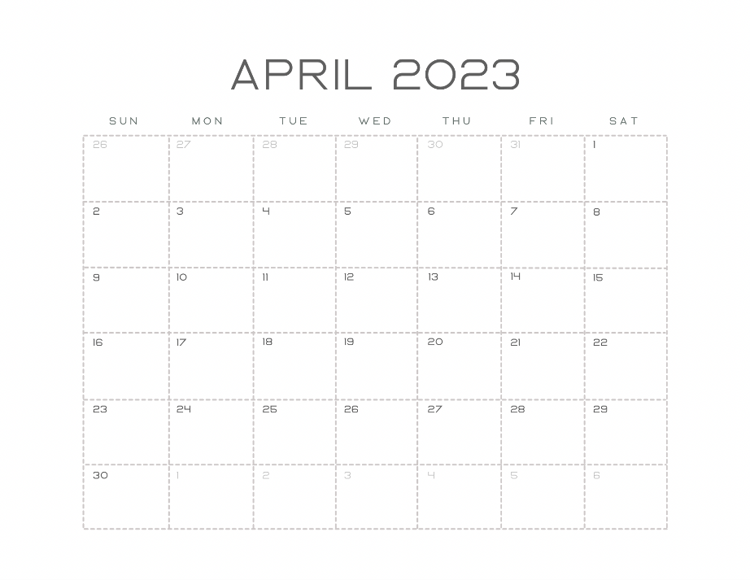
April 7, 2023: Stations of the Cross, Good Friday Service, and Passion Play (Times to be announced)
April 8, 2023: Easter Vigil Mass- Students in RCIA for Children will receive their Sacraments at this mass
April 9, 2023: No Class HAPPY EASTER CHRIST HAS RISEN
April 22, 2023: First Holy Communion 10am in the Church
April 30, 2023: Confirmation 3pm in Church

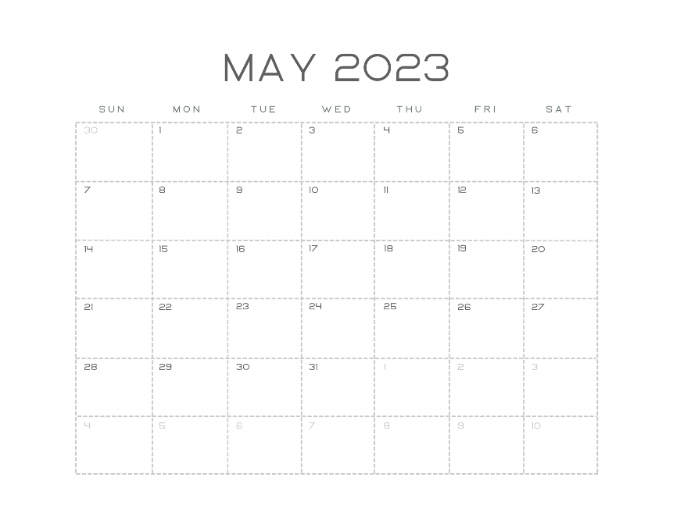

May 7, 2023: Last Day of Religious Education for ALL STUDENTS (This includes First Holy Communion Students and Confirmation Students; Classes DO NOT stop once the students have received the sacraments; they must return afterwards)

